PARISH NEWS
The Deverills & Crockerton

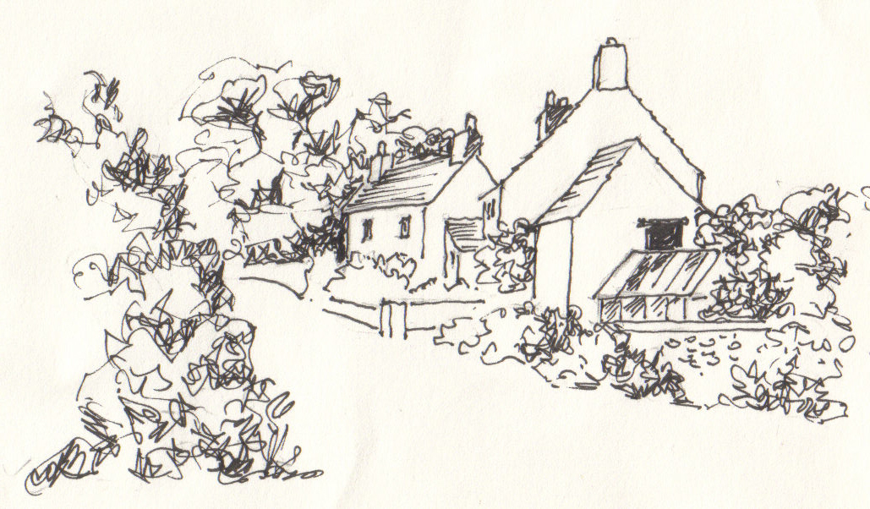

Monkton Deverill
by Pat Armstrong
July 2010

Look inside for local information

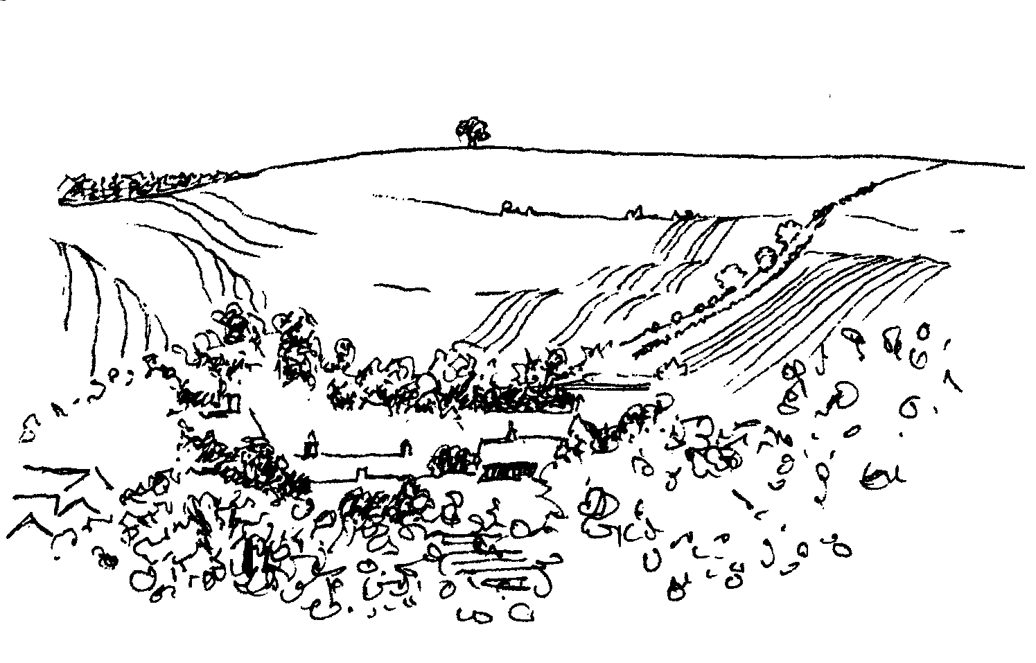
-2-

Farm Walk - Sunday 4th July
Manor Farm, Kingston Deverill from 2.00 pm onwards
Walking in groups on the Downs - about 2 miles
Stopping to discuss farming, wildlife and other issues
Dogs welcome, on leads please
Tea will be provided - Adults £5.oo - Children free
All proceeds to The Deverills Churches and Help for Heroes
Enquiries please call 844549

Coffee, Cards and Chat
Come and enjoy looking at the new range of cards,
ribbons, wrapping paper, and other exciting items
displayed by John and Maddie Goodden
in the Upper Deverills Village Hall on Thursday 19th February
between 10.30 and 12.00 noon - everyone is welcome
Donations will be made to the hall and the church

CROCKERTON VILLAGE COMMITTEE
Summer Party
10th ANNIVERSARY CELEBRATION
MILLENNIUM PEACE GARDEN (By School)
Sunday 4th July from 3.00 pm
3.30 pm original committee photograph, 4.00 pm tea & cakes on the Green (school open in the event of inclement weather) EVERYONE WELCOME

Parish Lunch
In a Marquee on the Cricket Field at Kingston Deverill
Sunday 11th July
12.30 pm for 1.00 pm
Please bring your own drinks & glasses
Adults £10.00, Children £5.00
Proceeds will go to Church Funds
Tickets: Sylvia Titt 214825 or Janet Budgen 218203

Quiz Night in Longbridge Deverill Hall

Saturday 17th July from 7.00 to start at 7.30 pm

Fish & Chip supper
Bring your own drinks All ages welcome
Teams of six can be made up on the night
Tickets £6.00 from Sylvia Titt 214825 or Pat Wood 840535

-3-
Rev Di Britten writes:
I am just about to embark on a shopping trip to select my holiday reading material. I am looking forward to our annual holiday, as I am sure many of you are, with all the space and time it potentially offers for rest and relaxation and restoration. We all have our own individual ways of achieving this. For many of us, holidays are exciting times where we seek the opportunity to go to new places or try out new and different activities and the phrase ‘a change is as good as a rest’ comes to mind! However, the holiday gives us all a time ‘to be still’, a time to stop and to reflect on our lives.
One of my favourite religious authors is Stephen Cottrell, Bishop of Chelmsford, who has written a brilliant book about taking time out, called ‘Do nothing to change your life’. It is about discovering what happens when you do stop. Most of us live lives at break-neck speed, busy lives with work, family, friends and endless tasks, which leaves us with little time to sleep, never mind stopping and reflecting. Bishop Stephen suggests that through a holiday, or at any other time, we start the adventure of self discovery, play and renewed creativity that will improve the way we see life and to help us catch a glimpse of God. To give thanks for the life we have, to marvel more at the world of which we are a part and to re-acquaint ourselves in our relationship with God.
There are many different ways in which we can take time out to stop and to draw breath, apart from packing our suitcase or reading Stephen’s book. Quiet days are offered by many of the Christian retreats across the country, one of which is on our doorstep, Ivy House Warminster. A new and different way of enjoying a day away is by visiting Great Chalfield Manor, near Melksham, and spending a quiet, led retreat, in the beautiful garden there. However we might be spending our holiday take time to Be Still to find the presence of God around us and within us.
Thank you
At the beginning of June Mike and Barbara Beilby left Kingston Deverill to live in Ferndown. We were very sorry to see them move and thank them for all that they contributed to the life of the village. Mike and Barbara not only played an active part in the life of the church but were a visible presence (as was Benson) in the village. Their quiet friendliness welcomed everyone and their observations and work cared for, and enhanced, the fabric of the village. We particularly remember Mike’s work on the Parish Council and as Emergency Officer, and Barbara’s work with the Thursday Group. We thank them and wish them every happiness in their new home.
Alice Stratton and Norma Payne
A message from the Beilbys
By the time you read this we will have moved to Dorset. Forgive us if we didn’t say au revoir to all our friends and neighbours in the Deverills and Crockerton but events went very quickly. We have, over the past twelve years, very much enjoyed being part of village life in Kingston and have many happy memories. The valley will always have a special place in our thoughts and prayers. Benson is enjoying his new walks on the heath and beaches, as we are. We thank all who sent good luck cards and hope to see you soon. Our new address is: 3 Linton Lawns, 141-143 Golf Links Road, Ferndown, Dorset, BH22 8BX. Fondest regards, Barbara, Mike & Benson

-4-

Maiden Bradley Village Hall
Friday 23rd July 7.30 pm
Entertaining Musical Evening with Wine & Cheese
Featuring AMATA MUSICA - chamber music ensemble
Piano - Margaret Lynn, Flute - Leslie Shiells, Oboe - Jane Finch,
Clarinet - Colin Parr, Bassoon - Martin Gatt, Horn - Sue Dent
A variety of Music - Mozart, Bizet, Haydn, Fauré
Tickets from £12 Martin Gatt 844787, The Old Post Office, Kingston



SATURDAY 11TH SEPTEMBER
SUPPORT
THE WILTSHIRE
HISTORIC CHURCHES TRUST
TO TAKE PART
PLEASE CONTACT
JUDY MUNRO 844385

THE ANONYMOUS TRAVELLING MARKET
@ The Cattle Market, Christy’s Lane, Shaftesbury, SP7 8PH
Every last Saturday of the month (except August) & travelling to.....
Pythouse Kitchen Garden, Nr Tisbury SP3 6PA
Saturday 17th July 11.00 am - 4.00 pm
No dogs please. Live Music at all markets. Cash & cheques only.
Supported by Dorset Cereals. For more dates & stallholder information see: www.theanonymoustravellingmarket.co.uk Supported by Dorset Cereals
Salisbury Theatre Club Trips
Monday 13th September
A Voyage Round My Father
by John Mortimer
The cost is £17.00: theatre seat £12.00 and coach trip £5.00
Please book early to ensure tickets, payment in advance to Mary Stewart Cox
Tel 840877 at Longmead, Brixton Deverill, Warminster BA12 7EJ
Coach leaves Kingston Church 6.10 pm and collects through the Deverills
Performances begin at 7.30 pm

-5-
Longbridge Deverill Village Hall
New (M)aid for the kitchen
The Hall Committee would like to say a huge thank you to the Longbridge Deverill Social History Group for their most generous donation to the Village Hall. They have kindly provided a wonderful new cooker plus delivery and installation with the monies raised from the sale of their book. The committee really do appreciate it and can't wait to put it to full use. We are sure that it will make it easier to provide hot meals and that it will be a benefit to the hall for future bookings.
A Generous Cheque
We have again had a cheque from Longbridge Deverill garage for the sum of £534 for recycling. Many thanks to Rushdene via Willem for this generous amount. We are hoping before the year is out to repaint the inside of the hall. This amount will go some way to paying for this. All your efforts to recycle are recycled back into the community! Many thanks.
Pat Wood and Julie Read
See page 2 for details of our next event: Quiz Night on Saturday 17th July
Attention History Lovers!
To commemorate the start of WW1 the Codford & Local History Society cordially invite anyone interested in history to join a small group investigating the effect on their parish during the war of the encampments in the Valley. We need volunteers especially from Sherrington, Fisherton de la Mere, Sutton Veny and Longbridge Deverill to help prepare an exhibition in August 2014. Possibly interested? Please do call in the first instance either Barbara (850247) or Richard (850822) and see what they have already got on Boyton and Corton.
Longbridge Deverill and Crockerton Parish Council
Do you enjoy walking? VisitWiltshire is hoping to put two walks in our area on the VisitWiltshire website later this year. One starts at Shearwater and runs for 6.25 miles passed Swancombe Bottom, Shute Farm Cottage, Rye Hill and back through Foxholes. The other starts at The George and runs for 8 miles through Hill Deverill to Cold Kitchen Hill and back. VisitWiltshire are looking for volunteers to walk the route at least once a year to check that the instructions are correct and inform of any changes. They also need a short 150 word personal description of any special buildings or local history on the route. If anyone has any photographs of either walks they would also be appreciated and would be acknowledged on the website. If you feel that you could help to put our villages on the map, please contact me as soon as possible on 840119 so that I can give you all the necessary information and inform VisitWiltshire. The text has to be in by July 16th so there is not much time.
Don't forget that the next Parish Council meeting is on Monday 5th July 7.30 at Longbridge Deverill Hall. Anyone is welcome to attend.
Helen Few Clerk

-6-

Save the Children 2010
Cream teas and garden open in aid of Save the Children
This will be held at Mill Farm, Hill Deverill on Sunday 25th July from 3.00 pm - 6.00 pm (and on the last Sunday of the following two months). There will be cakes and plants for sale as well as other interesting items. Come and enjoy a relaxing afternoon in the barn or garden.
Anne Hurd
Deverill Valley & Crockerton Women's Institute
Early in June we enjoyed a visit to Kilver Court, Shepton Mallet, after an excellent lunch at a local pub. It was a very relaxing and enjoyable afternoon with tea at the gardens. We have also been busy with ‘Scrabble’ and ‘Skittles’. Our meeting this month will be Monday 12th July at 7.30 at Longbridge Deverill Village Hall and Sue Wilkins will speak and answer questions on ‘How to avoid being the Victim of a Scam’. This will be followed by tea, biscuits and a raffle. If you would like to know more about the WI in the Deverill Valley please contact Julie Wallder on 213142. You would be very welcome to join our meetings.
The Deverills Cricket Club
Home matches take place on the cricket ground next to the Upper Deverills Village Hall starting from 2.00 or 2.30 pm, please do come along to watch and support us. The home fixtures are on:
4th & 25th July, 1st, 22nd & 30th August, 12th September
If you would like to join the club and require further information please call Peter Child 01963 34593 or Jamie Fagan 844123 / 07796 698180.
Stourhead Show - Horses, Dogs and Country Fayre
Come to your exciting local show on Sunday 1st August in Home Park at Stourhead. Have lots of fun! A great family day out!
There is a companion dog show, come and enter your dog in any of the classes. It does not matter what type of dog! Classes range from obedience through to a dog that looks most like its owner!
See the lovely horse drawn carriages with single and pairs of horses.
Plenty of other horses with show jumping, dressage and all types of show and working horses including fancy dress for riders and their ponies!
New this year a country Fayre ring that will include a gun dog demonstration and terrier racing.
Stalls selling all sorts of things, refreshments, food and a beer bar.
The horse events run all day, with the dog classes starting mid morning until mid afternoon, gun dog training starts about 1.30pm and carriage driving about 2.00 pm. Come and have a fun day! For more details see www.stourheadshow.co.uk
(Charitable donations given to Riding for Disabled and a dogs home.)

-7-

Music for a summer evening
On Friday 16th July at 6.00 pm, the Clarino Ensemble will celebrate ‘Clarinets in the Classical Period’ on historical clarinets and basset horns including music by Mozart, Stadler, Haydn and Krommer, in the beautiful surroundings of Rockfield House, Nunney, in aid of Kampala Music School. A suggested donation of £10 a ticket will include refreshments. Please ring Claire Johnson 01373 836012.
Upper Deverills Parish Council
A vacancy has arisen on the Upper Deverills Parish Council for the Kingston Deverill ward. Any person willing to fill this vacancy should apply to the Clerk in writing on or before 14th July. The conditions for application are:
- Your name must appear on the current register of the Voters List; OR
- You should have lived in or within three miles of the parish during the whole of the last twelve months; OR
- Your only place of work during the whole of last twelve months is in the parish.
If you feel passionate about your parish and would like to join the team of Councillors, please write to the Clerk at the following address giving your reasons for joining the team. Sarah Jeffries AILCM Parish Clerk, 9 Beech Grove, Warminster, Wiltshire BA12 0AB or telephone 01985 213436 or email upperdeverillspc@o2.co.uk
The next Parish Council Meeting will take place on Wednesday 14th July at 6.30 pm in Upper Deverills Village Hall, everyone is very welcome to attend, and we look forward to seeing you.
Upper Deverills Broadband Action Group Report
May I start by inviting volunteers to join this action group. We would particularly benefit from anyone with IT skills or background and also from those wishing to see greatly improved broadband services in this community. Please consider joining. Contact Richard Kitson 844803 or Robin Greenwood 840743. Regrettably we were not successful in our bid for SWRDA funding when outcomes were published last month. A combined bid from the county councils of Somerset and Devon and one from Gloucestershire did win and we shall monitor their progress with their projects which are expected to be completed in the next 9 - 12 months.
Meanwhile we now find ourselves in a contemplative position i.e. considering as many as possible ways forward without falling over our feet in our haste to progress. To this end we are already taking action to establish:
How the new coalition Government proposes to take forward the roll out of better broadband and over what timescales? Our chairman wrote to Dr Murrison MP on 10 June 2010.
From BT to determine if they have reconsidered any medium/long term plans for Broadband in this rural community. So far it appears not to be the case.
Contacting organisations who are piloting the installation of Fibre to the home (FTTH) solutions in other parts of the country.
Councillor Robin Greenwood

-8-

The Deverills & Horningsham Register

Marriages

Caroline Searle & Oliver Popham at Longbridge Deverill Saturday 8th May

Beth Sims & John Saunders at Longbridge Deverill Saturday 29th May

Helen Knight & Jayme Rickards at Kingston Deverill Saturday 5th June

Lucy Campbell & George Hall at Kingston Deverill Saturday 12th June

Tina Lort & Tristan Woodward at Longbridge Deverill Friday 25th June

SERVICES PARISH OF DEVERILLS & HORNINGSHAM
Sunday Trinity 5
4th July Brixton 8.00 am Holy Communion 1662
Longbridge 10.30 am Morning Worship
Sunday Trinity 6
11th June Kingston 10.30 am Holy Communion
Horningsham 11.15 am Holy Communion
Sunday Trinity 7
18th July Longbridge 8.00 am Holy Communion 1662
Brixton 10.30 am Holy Communion
Horningsham 11.15 am Reunion Service
Sunday Trinity 8
25th July Longbridge 10.30 am Holy Communion
Horningsham 11.15 am Morning Prayer
Kingston 6.00 pm Evensong
Sunday Trinity 9
1st August Kingston 8.00 am Holy Communion 1662
Longbridge 10.30 am Morning Worship
Horningsham 6.30 pm Evensong

Tuesday, Wednesday, Thursday, Friday Longbridge 8.30 am Prayers
Wednesday Longbridge 10.15 am Holy Communion
Parish Prayer Group meeting - Deverills and Horningsham
Tuesday 6th July 7.00 pm to 8.00 pm at Mary Royall’s house (840338)

NB Bishop David Stancliffe retires in September, his last official engagement being the Ordination of Deacons on Saturday 3rd July, 11.00 am in the Cathedral. Afterwards everyone is invited to picnic on the cathedral green.

-9-
SERVICES PARISH OF CORSLEY & CHAPMANSLADE
Sunday Trinity 5
4th July Corsley 9.00 am Holy Communion
Sunday Trinity 6
11th July Chapmanslade 9.00 am Holy Communion
Temple 9.00 am Holy Communion 1662
Sunday Trinity 7
18th July Chapmanslade 9.00 am Holy Communion
Corsley 6.00 pm Holy Communion
Sunday Trinity 8
25th July Corsley 9.00 am Holy Communion
Temple 10.30 am Sea Sunday Service
Sunday Trinity 9
1st August Corsley 9.00 am Holy Communion

Church Cleaners for July
Kingston – Mandy Martyn & Trish Shuler
Brixton – Caroline Huntley & Frances McDonald
Longbridge - Monday 5th July 9.30 - 10.30 am - all helpers please
Church Flower Arrangers for February
 | Kingston | Brixton | Longbridge
4th July | Edith Dyer | Mrs Burridge | Janet Budgen
11th July | Edith Dyer | Lady Walker | Sue Jackson
18 July | Alice Stratton | Lady Walker | Sue Jackson
25th July | Alice Stratton | Mrs McDonald | Trish Birts

Contact the Clergy
Please contact Norma Payne (841321) or Di Britten (01373 832515) if anyone is housebound and would like communion or a visit at home;
or if someone is ill and needs our prayers; or to discuss any church matter.
Administrator phone 215460 or email: churchofstdenys@btconnect.com

Ivy House St Denys Retreat Centre
Monday 19th July - House Quiet Day with Ivy House Team
Monday 26th July - Quiet Garden Day
For bookings & information please ring 214824
-10-

Where have you been? The Woolpack, Sutton Veny (840422)
I am very grateful to Christie Burton of Monkton Deverill for this review.
It was the Friday evening of a bank holiday weekend and our first choice for dinner was fully booked. So we went to The Woolpack at Sutton Veny and we were glad we did. There were seven of us - four adults and three children: 7, 4 and 2½. The proprietor/waitress was welcoming and helpful and did not condescend to the children. They needed a soft drink and she brought them a carafe of apple juice. The adults - one of whom was driving - had two bottles of wine and a pint of beer.
But it was the food that would make us go back. The Woolpack menu includes a particularly delicious carpaccio of beef as a starter and Corinna and I had that in a main course size. Muiris and Barry - both of them no mean connoisseurs of confit of duck - agreed it was one of the best they had had. The duck was served on a bed of colcannon flavoured with mustard and sherry - it may sound odd, but it worked. A smoked chicken salad was ordered for Matthew, 7. At the first bite a look of ecstasy crossed his face: "Awesome," he said. The girls shared a burger cut horizontally, but each had a bun and sauté potatoes (no chips!). Those adults who pinched one or two thought they were definitely a cut above the usual.
Having had a starter each (two asparagus, one carpaccio and one goat's cheese with spiced pears), the adults only managed one portion of (very good) rhubarb syllabub. But children always like their ice cream and the elder two enjoyed their first taste of mango sorbet. Katie was happy with her vanilla ice cream. With one coffee, the bill came to £161.55.
Relatively recently refurbished, The Woolpack is only one room deep, and therefore quite small. The bar is on the right and the restaurant - ingeniously separated but not cut off from it - on the left. The tables have a deep shine and the chairs are comfortable and leather-upholstered.; it feels like a proper restaurant rather than a pub with food, but it is not formal or stuffy. Apart from our group, there was only a handful of other diners and we all felt it was a shame that the quality of the food had not attracted more customers.
If you have somewhere you would like to recommend, please send your comments and suggestions to me by email at farthings.kd@btinternet.com or through my letter box at Farthings, Kingston Deverill.
Trish Shuler
Recipe of the Month
Sponsored by Maiden Bradley Community Shop (844206)
Lazy summer soup (serve hot or cold) serves 2-3 or 4 as a starter
Ingredients
10 discs Aunt Bessie’s Homestyle frozen mashed potato
110g watercress, spinach, rocket salad - keep some watercress leaves aside to garnish
1 medium leek, trimmed, washed and sliced
4 thick or 6 medium spring onions, snipped into 3 pieces
425ml hot stock made from Marigold bouillon powder
150ml milk
1 teaspoon butter

CONTACT THE EDITOR AND WEBSITE
Parish News Editor - Judy Munro 844385
Contributions for the Parish News through my letterbox or
by post to Whitepits Lodge, Kingston Deverill, Warminster,
BA12 7HD or by Email: judymunro@tiscali.co.uk Thank you
Please remember the deadline is the 15th of every month

Website: www.deverills.org.uk Email address:info@deverills.org.uk
Website manager : Kate Wilkinson 844998
Contents: Parish News with church services, Parish Register, Events, Local News plus pictures and other information
-11-
Recipe - Method
In a medium saucepan melt butter, add sliced leek and spring onions. Stir them around, add some salt, put on lid and cook gently for 5 minutes. Add frozen potato, stock and milk and bring to simmering point. Give one good stir, cover and simmer gently for 20 minutes. Then off the heat add watercress, spinach and rocket leaves. Gently whiz soup to a puree with a blender – not too much, you will need to see the leaves. Taste and check the seasoning before serving, garnish with extra watercress.
Nature Notes
There is so much going on at this time of the year. Everywhere there is new life, whether it is the lush new growth of the hedgerows or the young birds demanding food from their very tolerant parents. Our garden is full of young birds: blackbirds, robins, great tits, blue tits, long-tailed tits, tree sparrows, goldfinches, swallows, greenfinches, chaffinches, starlings, the list goes on! The bird food is disappearing very rapidly. When in the nest the chicks are fed mainly with insects which are rich in protein, but once fledged the diet becomes more varied and the bird seed, peanuts, sunflower hearts and fat balls that we provide are very acceptable! We are fairly sure that there are six active swallow nests in the garage and at least one brood has flown already. All five house martin nests along the front of the house appear to be active and I can hear cheeping coming from the most westerly nest.
Out in the fields the roe deer are giving birth. Early one morning I had a lovely view of a roe doe suckling a very young fawn out in long grass at the top of the farm. It was so small and keeping very close to its mother. It may have only been born that morning; being a wild animal they are very quick to get up on their feet. For about the first ten days of life the fawn is left in long grass with the doe returning to suckle it two or three times a day, after which it is strong enough to follow wherever its mother goes. They are very well camouflaged in the long grass but very vulnerable at this stage, as they will not move from the spot where their mother has left them until called by her to come. Last Friday we had the mower in to cut several fields for silage, later in the day we saw a doe frantically looking in amongst the mown grass and then a buzzard. I quickly put two and two together and sure enough when we went out into the field we found a very small fawn that had gone through the mower. One young life cut very short. The next day in the evening a man was landing a micro light on the airstrip opposite our farm, and a deer ran out in front of him. Luckily he was not hurt but his aircraft was damaged and sadly the deer was killed. I went over to check out the animal and it was a doe in full milk (interestingly they have 4 teats like a cow). We think that it was the mother of the fawn that was caught in the mower, but we will never know for sure.
I have also witnessed two other young lives cut short courtesy of our local sparrow hawk; both attacks happened early morning. One was a starling who put up a very good fight but sadly in vain, and the second was a blackbird. It is just nature in the raw; the blackbird pulls up a worm for its meal, the sparrow hawk kills the blackbird, one of nature’s many food chains.
Jane Trollope (written on 15th June)

-12-
Upper Deverills Village Hall
Rounders and Family Fun Evening
This proved a very popular social occasion again; many families took part displaying a varying level of skill! Delicious refreshments were enjoyed at the barbeque afterwards. Thank you to those who made this such an enjoyable time.
Duck Race 5.30 for 6.00 pm Saturday 3rd July
Ducks are £1 each, collect your duck 1 week before the race to enter the Best Decorated Duck competition, contact John Lea (844325) at Newports Barn, Kingston Deverill, opposite Village Hall. Ducks will be on sale at Pope’s Bridge from 5.30 pm before the race. The Best Decorated Duck will be awarded a prize at 6.00 pm, before the race starts. There will be a barbeque in the field by the Old School Bridge afterwards where winners will receive their prizes. Great fun!
Annual Summer Fete 2.00 pm Saturday 17th July
The Fete will include the usual Flower and Craft competitions and the Dog Show as well as many of the popular sideshows and delicious cream teas. Details of the classes are opposite and an entry form is below. Please start planning your exhibits now! You can take part in as many categories as you wish! We welcome entries from everyone - the more we have the greater the competition and the more fun it is! It is not the winning but the taking part that counts! Please come and enjoy this fun event and enter something.

Upper Deverills Fete & Flower Show Entry Form
Saturday 17th July 2010
One exhibitor per entry form please. Entry forms to be submitted by Wednesday 14th July to: Richard Cousens, The Old Ostler’s House, 87 Monkton Deverill,
BA12 7EX, Tel: 844970 email: r.cousens@btinternet.com

Class No | Description of Class | Description of Item | Size

NB All exhibits to be at the Village Hall by 10.00 am on Saturday 17th July
Name:
Address:
Phone Number: Email:

(Late entries welcome on the day)
-13-
Upper Deverills Flower Show Schedule 2010

The Village Hall Cup for Classes 1 to 4
Class 1 – Vegetables & Fruit
1.1 Best collection of 4 Vegetables
1.2 A Salad Selection (Max 10”)
1.3 Largest leek, carrot or radish
1.4 Soft Fruit Selection (Max 10”)

Class 2 – Cookery (WI Cup)
2.1 Treacle Tart
2.2 6 decorated cup cakes
2.3 Home made chutney
2.4 6 Biscuits
2.5 Open class cake of own choice

Class 3 – Flowers 1
3.1 Specimen HT or Non Cluster Rose
3.2 6 Sweet Peas
3.3 Annuals – 6 stems – 1 or more varieties
3.4 Perennials – 6 stems – 1 or more varieties
3.5 Flowering shrubs – 3 different sprigs
3.6 A hanging basket

Class 4 – Flowers 2
4.1 Pelargonium (Geranium) in a pot
4.2 Foliage plant in a pot
4.3 Flowering pot plant (excluding 4.1)
4.4 An arrangement of wild flowers
4.5 Table arrangement with a Wiltshire theme

The Liz Peters Cup for Classes 5 & 6


Class 5 – Photographs
5.1 Disgraceful Deverill Doggies
5.2 Wiltshire wildlife
5.3 My Schooldays
5.4 A hugely embarrassing party snap
5.5 Classic Cars

Class 6 – Arts and Crafts
6.1 Needlepoint or Cross Stitch article
6.2 A handwritten limerick (both handwriting and humour will be judged)
6.3 A knitted item
6.4 A painting or drawing (completed since August 2009)
6.5 A stone or wood carving
6.6 An upholstered item

The Junior Shield

Class 7 – 11 Years and under
7.1 ‘Village pond’ – Garden on a tray
7.2 A painting of your house
7.3 4 decorated fairy cakes
7.4 Home grown flowers or vegetables
7.5 A home-made birthday card
7.6 A Lego or Airfix model
-14-

LOCAL COUNCILS, SOCIETIES, GROUPS etc.
Longbridge Deverill and Crockerton Parish Council
Karen Manfield 215285 (Chair) Peter Whithey 840347 (Vice Chair)
Helen Few 840119 (Clerk) Thomas Minter 216909
Bill Hurd 840023 Elaine Pidgeon 212878
Julian Algar 840816 Graham Read 840296
Brian Marshall 214789
Upper Deverills Parish Council
Lady Felicity Wheeler 844683 (Chair) Ranald Blue 841374
Sarah Jeffries 213436 (Clerk) Patricia Shuler 844291
Sarah Fagan 844123 Robin Greenwood 840743
Wiltshire Councillor
Fleur de Rhé Philipe 213193

Wiltshire Council 0300 456 0100

Longbridge Deverill Village Hall Committee
Pat Wood 840535 (Chair) Julie Read 840655 (Secretary) Sylvia Titt 214825 Caretaker)

Upper Deverills Village Hall
Richard Cousens 844970 (Chair)
Mandy Martyn 844320 (Secretary) John Lea 844325 (Hall bookings)

Crockerton Millennium Committee
Marion Thomas 213739 (Chair)

Pre-School Children and Parents ‘Thursday Group’
Sylvia Titt 214825 Pat Wood 840535

Deverill Valley & Crockerton W I
Ruth Sutton (President) Julie Wallder 213142 (Secretary)

Sir James Thynne Almshouse
Mrs Sue Jackson 840322 (Steward)

Deverills Cricket Club
Jamie Fagan 844123 Peter Child 01963 34593

Wylye Valley Tennis Club
Colin Singer 213696

Wylye Valley Flower Club
Mrs Hazel Yate 215617 (President) Mrs S Scott 216584 (Programme Secretary)

Wiltshire Wildlife Trust
Elm Tree Court, Long Street, Devizes SN10 1NJ www.wiltshirewildlife.org

Rural Community Beat Manager - Police Community Support Officers
PC Vicky Pegrum - PCSOs Ian Owen & Caroline Wright - 0845 408 7000

Hospital Transport Link Scheme 211655

-15-

F O R T H C O M I N G E V E N T S
Forthcoming Events
- Scottish Dancing Monday Evenings Aline Fry (841054)
- Tennis Coaching 9.30 am Tuesday Mornings Judith Hirons (845255)
- Bell Ringing at Longbridge Wednesdays 7.30 pm Richard Munro (844385)
- Hearing Loss Lip-reading Wednesdays Margaret Head (213259)
- Pre-school & Parents Group Thursdays 10.00 - 11.30 am See p14
- Deverills Chamber Choir Fridays 7.30 pm Claire Johnson (01373 836012)
- Bishops David’s last event at Salisbury Cathedral Saturday 3rd July See p8
- Duck Race Saturday 3rd July See p12
- Farm Walk Sunday 4th July See p2
- Summer Party Sunday 4th July See p2
- Deverills Cricket Club Sundays 4th & 25th July See p6
- Longbridge & Crockerton Parish Council meeting 7.30 pm Monday 5th July at Longbridge Village Hall See p5/14
- Parish Prayer Group Tuesday 6th July See p8
- Parish Lunch Sunday 11th July See p2
- WI Meeting Monday 12th July See p6
- Wylye Valley Flower Club Demonstration Tuesday 13th July See p14
- Upper Deverills Parish Council meeting 6.30 pm Wednesday 14th July at
Upper Deverills Village Hall See p7/14
- Clarino Ensemble Friday 16th July See p7
- Anonymous Travelling Market Saturday 17th July See p4
- Summer Fete Saturday 17th July See p12/13
- Quiz Night Longbridge Deverill Village Hall Saturday 17th July See p2/5
- Ivy House Quiet Days Mondays 19th July & 26th July See p9
- Amata Musica Friday 23rd July See p4
- Save the Children Teas Sunday 25th July See p6
- Stourhead Show Sunday 1st August See p6
- Deverills Cricket Club Sundays 1st, 22nd & Monday 30th August See p6

F O R T H C O M I N G E V E N T S
16-
Contact the Editor and the Website

Parish News Editor: Judy Munro 844385
Contributions for the Parish News through my letterbox or
by post to Whitepits Lodge, Kingston Deverill, Warminster,
BA12 7HD or by Email: judymunro@tiscali.co.uk Thank you
Please remember the deadline is the 15th of every month

Website: www.deverills.org.uk
Email address: info@deverills.org.uk
Website manager: Kate Wilkinson 844998
Contents: Parish News with church services, Parish Register, Events,
Local news plus pictures and other information
PARISH OF DEVERILLS AND HORNINGSHAM
Churches
SS Peter & Paul the Apostles Longbridge Deverill
St Michael the Archangel Brixton Deverill
St Mary the Virgin Kingston Deverill
St John the Baptist Horningsham
Rector
Rev Norma Payne, 6 Homefields, Longbridge Deverill 841321
Clergy
Rev Diana Britten, 69 Lane End, Corsley 01373 832515
Licensed Lay Ministers
Mr John Budgen 218203
Col Robin Chappell 212153
Churchwardens
Mrs Elisabeth Atkinson (Longbridge Deverill) 212129
Mrs Mary Stewart Cox (Brixton Deverill) 840877
Major Mike Tulloch (Kingston Deverill) 844381
Mr Tim Moore (Horningsham) 844336
PCC Treasurer Mr David Stratton 844549
PCC Secretary Mr Nigel Poole 840902
Church Electoral Roll Officer Major Mike Tulloch 844381
Parish News Editor Mrs Judy Munro 844385
Organist Mr John Budgen 218203
Bell Tower Captain - Longbridge Mr Steven Young 212796
Caretaker - Longbridge Church Mrs Sylvia Titt 214825
Office Administrator Mr Dick Collins 215460
(Mon -Thurs 10.00 - 12.00) St Denys, Warminster

